Exercises on High Voltage Engineering (April 24, 2025)

Yuanxiang Zhou

**Exercise 6-2: 需对一台 66kV/10kV/10000kV·A 的电力变压器进行高压绕组对低压绕组和铁芯、铁外壳进行工频耐压试验。已知高压绕组对低压绕组及地的电容量为6200pF，试验电压为 140kV。请选择一台合适的高压试验变压器的额定电压及容量。**

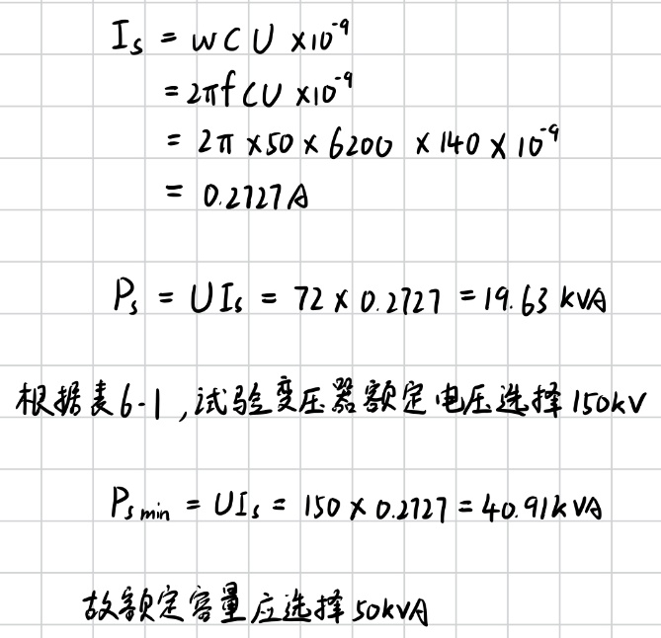

**Exercise 6-8: 用 3 台输出额定电压均为 750kV 且变比均为 75 的变压器串联而成一串级试验变压器，该串级试验变压器输出的额定电压为 2250kV，额定容量为 4500kV·A，则三台变压器低压侧、高压侧流过的电流各为多少A？**

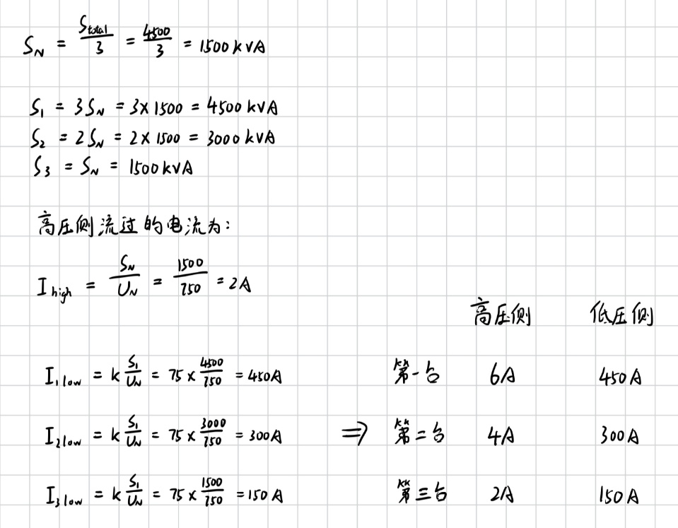

**Supplementary Exercise 1:** Between the electrodes of parallel plate capacitors, there are two layers of dielectric with the dielectric interfaces parallel to the electrodes. The electrical properties of the two layers of dielectric are as shown in the table below.

|  |  |  |  |  |
| --- | --- | --- | --- | --- |
| Dielectric | Thickness (mm) | *ε*r | tan*δ* (50 Hz) | *ρ* (Ω·cm) |
| 1 | 5 | 2 | 5×10-4 | 1016 |
| 2 | 3 | 6 | 3×10-3 | 1016 |

Assuming a 50 Hz voltage (rms) of 10 kV is applied between the electrodes, please calculate:

1. The electric field strength in each layer;
2. The capacitance per square centimeter of electrode area for the capacitor (*ε*0 =0.8854×1013 F/cm);
3. The dielectric loss per unit volume in each layer, W/cm3.

(If a DC voltage of 10 kV is applied between the electrodes, calculate after reaching a stable state)

1. The electric field strength in each layer;
2. The dielectric loss per unit volume in each layer, W/cm3;
3. The charge density accumulated on the interface, C/cm2;
4. The time constant for discharge when the capacitor is short-circuited.

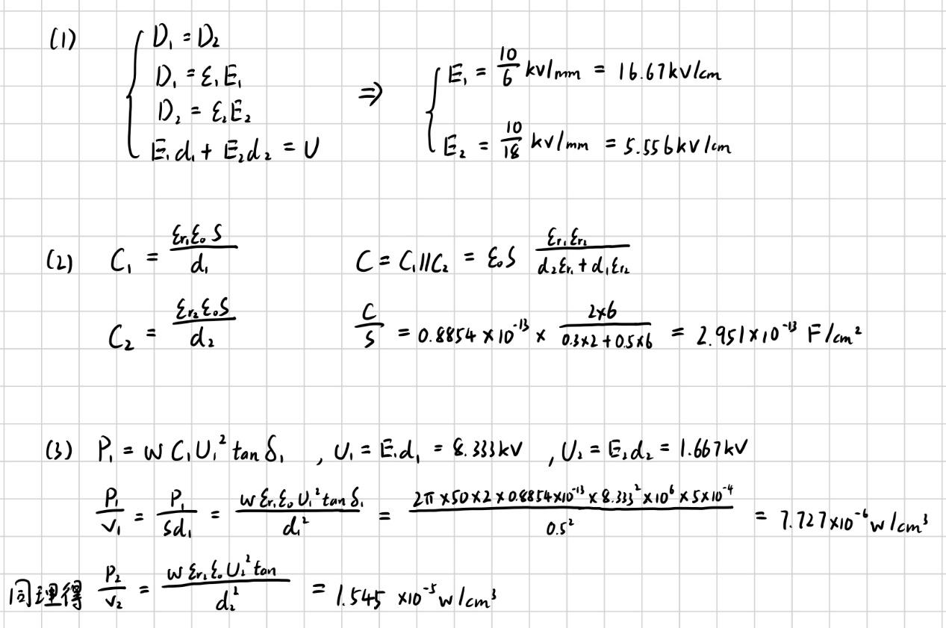

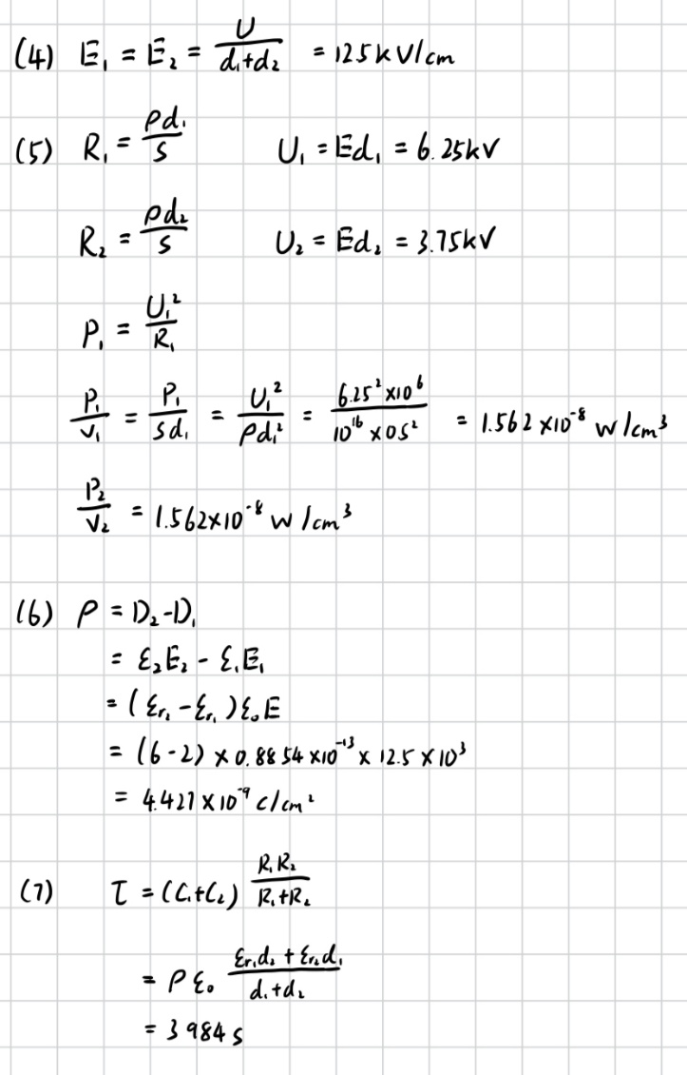

**Supplementary Exercise 2:** If the multi-layer dielectric insulation is considered as two capacitors in series (*C*1=0.1 μF, *C*2=0.2 μF) and in parallel with two resistors (*R*1=10 MΩ, *R*2=20 MΩ), connected to a DC power supply of 3 kV. When the switch is closed, the voltage distributes inversely proportional to capacitance. After stabilization, the voltage distributes inversely proportional to conductance. How much charge will accumulate on the dielectric interface during the process?

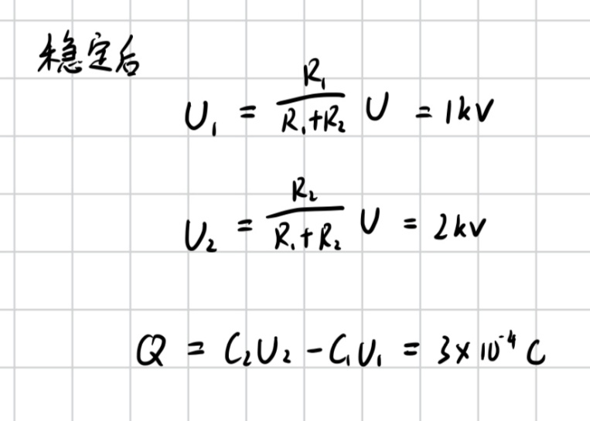

**Supplementary Exercise 3:** Tsinghua University has a 500 kV/500 kVA test transformer with a protection resistance *R* of 50 kΩ. What is the maximum capacitance of the test sample that can be connected under the rated test voltage?

